A pd/GEM object to import 3D animations
Javier García (tirengarfio@hotmail.com)

Abstract

These days, pd/GEM can load a .obj 3D model file from the object called [model], to show it in a GEM window. Once you have loaded the model, you can spin it on its three axis (XYZ), and move it also in all directions (XYZ).

But the 3D models that [model] can load are only inanimate, so it is for sure some pd/GEM miss sometimes import animated models.

My proposal is creating an object called [amodel_md2] to load 3D animations to a GEM window, exactly MD2 animations.

The 3D animation format: MD2

In 1997, id Software introduced a well known First Person Shooter (FPS) game: Quake II, for which they created a special format to model the characters of the game, called MD2 (.md2).

Some of the features of MD2 format are:

- Open source.
- Frame-by-frame animations.
- Based on skeletal animation technic.
- Low-polygon format (low-fi aesthetics)
- Works on little endian architectures only.

Dispite of the time, the comunity of gamers is still developing animated characters using this format, which they include in the games they also develop and share with other FPS game developers and users.

Though the most of the examples of .md2 animations we can find in internet are related to first FPS games, there are modellers to create MD2 animations. Besides, as usually in formats issue, it is possible to convert animations in other formats to .md2.

MD2 is also the first of a series of animation formats that goes together the releases of Quake (Quake 3, Quake 4, Quake 5): .md3, .md4, .md5, ...

About the GEM object: [amodel_md2]

The object will have an inlet (argument) to control the frames of the animation. That means having the option of handling the speed and the direction (forward and backward) of the animation.

Other inlets to implement would be related to:

- Resizing the 3D model
- Texturizing of the object.
- Etc.

The Schedule

Activity | February | March | April | May | June
Learn basics of OpenGL
Learn to create a pd/GEM object
Learn the .md2 format / create a viewer
Implement the object [amodel_md2]
Write documentation

Images and links

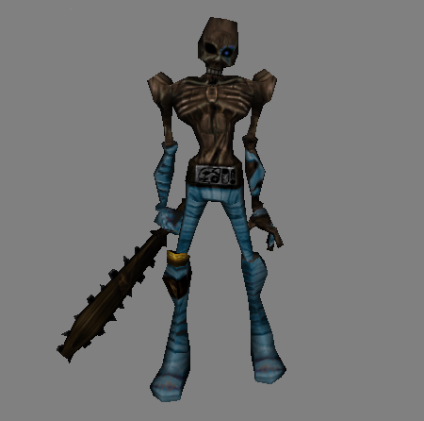

An example of a MD2 model

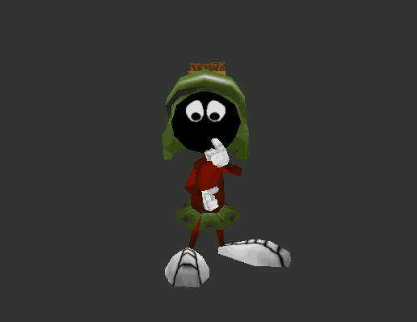

Another example of an MD2 model not so aggressive...

An example of an MD2 animation:

http://www.youtube.com/watch?v=jD9DrHr8jwU

An example of a matrix formed by the same animated model but delayed in time:

http://www.youtube.com/watch?v=qmrFZKtBxIU&feature=related

Some information about .md2 files:

http://tfcduke.developpez.com/tutoriel/format/md2/

_ - _

